Time to Celebrate..!!

WFS is Celebrating 54 Years of
Continuous Service in
Central Oregon

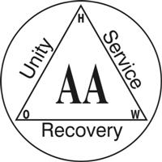

Join Us On
Wednesday, May 7th

Potluck @ 6:00 PM
Speaker Meeting @ 7:30 PM
Two Speakers &
History of AA in Central Oregon

Discovery Christian Church
334 NW Newport

